TITLE PAGE

**Patterns of influence in wild moving meerkat groups (working title)**

Baptiste Averly1,2,3,, Vivek H. Sridhar2,3,, Vlad Demartsev1,2,3,4, Gabriella Gall1,2,3,4,5, Marta Manser4,5,*, Ariana Strandburg-Peshkin1,2,3,4,*

1. Department of Biology, University of Konstanz, Konstanz, Germany
2. Department for the Ecology of Animal Societies, Max Planck Institute of Animal Behavior, Konstanz, Germany
3. Centre for the Advanced Study of Collective Behaviour, University of Konstanz, Konstanz, Germany
4. Department of Evolutionary Biology and Environmental Studies, University of Zurich, Zurich, Switzerland
5. Kalahari Meerkat Project, Kuruman River Reserve, Northern Cape, South Africa

*joint senior author

**ABSTRACT**

**INTRODUCTION**

In social animals, individuals often have heterogenous contributions to group decisions. In a given instance, group members whose actions cause others to change their behavior can be said to exert influence, regardless of their intention, but the distribution and consistency of influence can vary between individuals over multiple instances (Strandburg-Peshkin et al. 2018; Garland et al. 2018). Influence patterns has proven hard to assess and compare between social groups in the wild for a number of reasons. First, each species, and to some extent each group within a species, have their own characteristics, in terms of group size and composition, social structure, or type of movement and cohesion mechanisms, which has the potential to create a great variety of influence patterns. Then, within a given group, individual influence can be highly variable, likely depending on changes in environmental or social context, or on transient individual traits like physiological status or foraging success. to define and quantify influence in social system one requires knowledge about the decision-making mechanisms at play and about which type of cues from a given individual are of particular relevance in influencing the decisions of others. In the context of movement, these cues can include position in space, movement in a given direction, specific vocalizations… It has been shown through models and lab experiments that the movement of a given individual in a group is strongly influenced by the relative position of its neighbors (Couzin et al. 2005), but it is unclear to what extent this is generally true in the wild. Additionally?, since individual influence is relative to the type of decision being considered, influence over one type of group decision does not necessarily translate into influence over other types. For instance, movement decisions encompass decisions both about where to go and about when to go, which can have discrete vs continuous consensus costs respectively (Conradt and Roper 2010), but it is not well known whether the individuals in a given group that have high influence over the group’s direction of movement also have more influence on the group’s speed or timing of departure. Influence is therefore a highly versatile notion and it is crucial to define the context in which it is looked at and to have a thorough understanding of the system’s biology to assess it accurately.

In recent years, there has been a surge in studies trying to assess influence dynamics in wild moving animal groups, thanks to a reduction in cost and size of tracking technologies allowing the simultaneous recording of multiple individuals (Hughey et al. 2018). Such studies have been looking separately at questions like who has influence over direction of travel (Kerth et al. 2006; Nagy et al. 2010; Giuggioli et al. 2015), who has influence over timing of departure (Strandburg-Peshkin et al. 2015; Tokuyama and Furuichi 2017; Montanari et al. 2021), or who is in the front of the group (Lewis et al. 2011; Van Belle et al. 2013; Smith et al. 2015), furthering our understanding of decisions-making mechanisms during movement. They have for instance highlighted the diversity of such mechanisms found in nature, from systems where influence is mostly distributed (e.g. in baboons, Strandburg-Peshkin et al. 2015) to systems where it is mostly concentrated. A positive link between influence and social rank has also often been established (Smith et al. 2015), though systems with influential subordinates are also found (Papageorgiou and Farine 2020). Few studies have look simultaneously at several measures of influence within one system in order to evaluate if individuals which have influence over direction of movement also have influence over speed or travel (Katz et al. 2011; Herbert-Read 2016), or to validate the assumption that frontmost individuals do have more influence (Pettit et al. 2015; Jolles et al. 2017), and even fewer in wild animals. In addition, it is not always clear what type of individual cues are most influential over group movement characteristics like direction and speed of travel. Pursuing the assessment of influence dynamics in as many species as possible is crucial in order to draw a broader picture of influence patterns and mechanisms across social systems.

Meerkats (*Suricata suricatta)* are an ideal system in which to investigate influence dynamics. Thesesocial mongooses live in groups of up to 50 individuals, in the arid parts of southern Africa (Doolan and Macdonald 1997; Manser and Clutton‐Brock 2016). Meerkat group members sleep together inside communal burrows at night and continually move as a cohesive unit throughout their 2-5 km2 territory (Kranstauber et al. 2019) in search of food during the day. Group splits may happen very rarely (Strandburg-Peshkin et al. 2019) and never last more than a couple of hours. Meerkats are opportunistic generalists, their diet being mainly composed of small invertebrates that they dig out of the ground (S. Doolan and Macdonald 1996), therefore food resource is not clumped like for several other social species (Ref capuchins, dolphins,…?) but rather distributed across the desert landscape. This particularity is reflected in the groups’ movement dynamics: rather than alternating clearly distinct foraging and moving phases, most of time the group as a whole is slowly travelling across the environment in a cohesive manner, while all individuals are independently foraging a few meters apart from each other. Discrete initiation of group movement, by single individuals? do also happen, mainly through the use of specific calls (Bousquet et al. 2011). Meerkats have a highly developed vocal repertoire (Manser et al. 2014) and calls have been shown to play an important role in maintaining cohesion (Gall and Manser 2017) or in mechanisms of shared decision-making (Bousquet et al. 2011), yet much remains unclear about how influence is distributed among group members during movement. Particularly, though meerkat groups are socially structured with two dominant individuals monopolizing most of the breeding (Clutton-Brock et al. 2001; Griffin et al. 2003), and no strong social hierarchy between subordinate group members, there are few evidences that dominance status also translates to more influence during non-breeding activities such as foraging (Bousquet and Manser 2011; Gall et al. 2017; Strandburg-Peshkin et al. 2020). Their particular social structure and movement dynamics, make meerkat an interesting model species to further our understanding of the diversity of collective movement mechanisms in the wild.

Here, we implement a simple method to infer individual influence from high resolution GPS tracking of wild habituated meerkats in five social groups of varying sizes. Because of the particular type of meerkat collective movement described above, this study does not focus on particular events at the transition between foraging and moving, but rather aims to capture an aggregated measure of influence over continuous foraging times. We designed it to explicitly differentiate and compare influence over two complementary components of moving animal groups, direction of movement (=**turning influence**) and speed of movement (=**speeding influence**), as affected by ?? two potential cues, position within the group and movement in a given direction. Since frontmost individual are often assumed to have more influence during collective movement, we compared our metrics of influence with the proportion of time spent in the front half of the group, to try and assess if this is true in meerkats. Our questions are thus the following: (1) Are meerkats more influenced by the position of others within the group or their movement in specific directions? (2) Are there consistent patterns of influence between age classes across different meerkat groups? (3) Do individuals which have high influence over direction of movement also have a high influence over speed and vice-versa? (4) Are individuals with more turning or speeding influence also the ones who are generally more in the front of the group?

**METHODS**

**Study site and data collection**

*Study system*

The study was conducted at the Kalahari Meerkat Project (KMP) within the Kuruman River Reserve in South Africa (26°58′S, 21°49′E, (Clutton-Brock et al. 1999) , where 7-15 meerkat groups are brought to a very high level of habituation to humans and monitored on a regular basis all year round. We collected simultaneous, high-resolution (1 Hz) movement data on the majority of individuals within five distinct habituated meerkat groups: HM17 (7 individuals) in August and September 2017, HM19 (18 individuals) in June and July 2019, L19 (19 individuals) in August 2019, ZU21 (13 individuals) in May 2021 and NQ21 (11 individuals) in August 2021. We chose the groups with the highest levels of habituation among the monitored population to enable collars to be deployed without the need for capture (see below). Individuals were attributed one of six different statuses, based on ongoing classification at the KMP: dominant females (one per group), dominant males (one per group), other adults (2+ years), yearlings (<2 years), sub-adults (<1 year) and juveniles (<3 months). Three individuals were present both in HM17 and HM19, with different statuses (see Supplemental Table 1).

*Tag design*

To simultaneously record the trajectories of all individuals in a meerkat group, we designed small (<25 g) collars consisting of a GPS unit (Gipsy 5 in 2017 and 2019, Axy-Trek Mini in 2021, Technosmart, Colleverde, Italy) and its battery (ER14250M) fixed on 5 mm-wide leather strap and protected from shocks and sand by wrapping in parafilm and covering with 2-part epoxy glue. Collars also included a small audio recorder (Edic-mini Tiny+ A77, Ts-Market, Russia), and Axy-Trek units in 2021 were also collecting accelerometry data, but only GPS data was used in the present study. The length of the strap was adjusted individually for each meerkat based on prior neck measurements. The closing mechanism consisted of 2 magnets (1*5*5mm) glued to 3-D printed plastic clasps at each end of the leather strap, designed to be able to close easily but to require human intervention to open. Completed collars weighed between 22 and 25g, which was never more than 5% of the wearer’s body mass. Once fitted on a meerkat, the GPS board rested on back of the neck, with the whip antenna pointing down the back of the individual (Figure 1a).

*Collar deployment, duty cycle and retrieval*

In winter months, meerkats typically spend up to an hour in the morning at their communal sleeping burrow before moving off to forage. During this time, they are typically relaxed and often stand upright in the sun to warm up or groom one another, thus presenting an ideal opportunity for non-invasive collar deployment. To deploy collars, one person would slowly approach a meerkat and start grooming its neck to test receptivity. If the target remained stationary and showed no sign of discomfort, the person would then try to clasp an appropriately-sized collar around its neck, stopping if the meerkat recoiled or moved away. To collar some individuals, a second person presented a water bottle to distract them, and the collar was clasped around the outstretched neck of the drinking meerkat. After two failed attempts for a given individual, it would be left alone for the rest of the day to prevent any risk of de-habituation. After successful collaring, individuals were observed for at least ten minutes and the collar was removed if they exhibited any kind of unusual behavior for more than a few minutes (e.g. scratching at the collar, trying to remove it). This happened in very few cases, always on the smallest individuals. In these few cases we removed the collars and in some instances re-deployed different collars on a subsequent day (if collar fit was determined to be the issue). At the end of data collection, collars were taken off much in the same way as they were put on or by cutting the leather straps using mini diagonal cutters, though sometimes as well during foraging since removal could be done much more quickly and easily than deployment. Juvenile individuals were below the minimal size for fitting a GPS collar, therefore their movement could not be recorded. All GPS units in a given group were synchronized to start on the same day and to record at 1 GPS fix/second for 3 hours every day, either in the morning after the group had left the sleeping burrow, or in the afternoon before returning to it depending on the deployment round. These are times when meerkats are foraging freely within their territory and are usually the most active. Recording duration for a single deployment round ranged from 6 days to 10 days depending on GPS-battery life. See Supplemental Table X for detailed information on group composition and deployment timing.

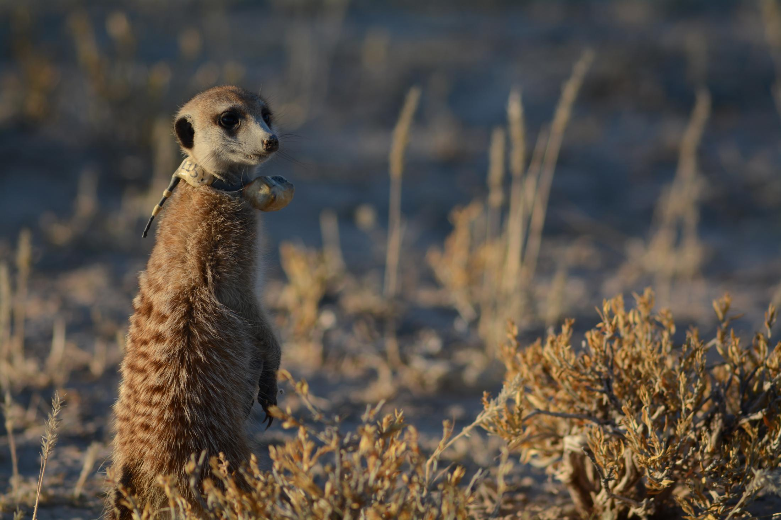

**battery**

**GPS**

**unit**

**antenna**

*Focal recordings of untagged individuals and scans*

Some non-juvenile individuals that could not be collared via the methods described above were instead continuously recorded by a human observer. A GPS tag equivalent to those deployed in collars was strapped to the end of a telescopic pole and thus kept within 1 meter of the foraging meerkat for the duration of each session. At the same time, the observer was vocally describing the focal meerkat’s behavior in a handheld microphone, including occasional moments when it was getting out of range of the pole so that these portions could be removed from the recorded trajectories. We then processed the data of the uncollared individuals exactly in the same way as data from meerkats wearing a collar (see below). Another person performed scans by noting in a tablet when specific events would happen on an all-occurrence basis (predator alarm, encounter with another group, etc…). The numbers of meerkats which could be focal-followed depended on the number of persons available (never more than 3), therefore not every non-juvenile could be recorded on every day, especially as GPS tags started failing due to low battery towards the end of the deployment round.

*Data pre-processing*

To increase GPS reliability and reduce sampling biases we pre-processed the data before subsequent analyses, by undertaking the following steps.

When GPS signals were not recorded continuously we discarded all fixes taken 30s before signal loss and 30s after retrieval. Similarly, we removed fixes with fewer than 5 satellites detected.  We also removed data suggesting biologically unrealistic speeds (> 10 m displacement between 2 fixes 1 second apart) as these likely represented GPS errors. Coordinates were converted from WGS84 to UTM S34 to allow for easier spatial analyses.

Moments where fewer than 2/3 of the non-juveniles present were recorded were removed to reduce the impacts of “invisible” (untracked) individuals.

We also removed predator alarms and one instance of encounter with another group identified using scan data, as these specific contexts are likely to be non-representative of typical meerkat group movement during foraging. One individual would occasionally be away from the rest of the group during recording times, either at the communal burrow on babysitting duty or out travelling on their own (“roving” behavior exhibited by adult males before leaving their natal territory for good). In such instances the GPS track of that given individual was discarded but the analyses were performed normally on the rest of the group. One day was removed from the analysis because the dominant male of HM19 had left the group with two other adult males and we thought this might affect too much the rest of the group’s dynamic.

**Analysis**

*Summary of the process:*

In order to assess the consistency of individual influence from the GPS tracks we collected, we defined two complementary metrics, **turning influence** representing a focal individual’s influence over the direction of travel of the group (along the left-right axis of movement, figure X), and **speeding influence** representing a focal individual’s influence over the speed of travel of the group (along the front-back axis of movement). Each metric comes in two different versions, depending on what type of cue from the focal individual is considered (position within the group or movement in a given direction). **Position turning influence** therefore tries to answer the question “does the left-right position of a given individual influences the group’s direction of travel?” and is defined as the probability that the rest of the group turns toward a given direction (left or right) as a function of the left-right position of the focal individual, while **movement turning influence** tries to answer the question “does the left-right movement of a given individual influences the group’s direction of travel?” and is defined as the probability that the rest of the group turns toward a given direction as a function of the focal individual’s speed along the left-right axis of movement. Similarly, **position speeding influence** tries to answer the question “does the front-back position of a given individual influences group speed?” and is defined as the probability that the rest of the group speeds up as a function of the front-back position of an individual, while **movement speeding influence** tries to answer the question “does the front-back movement of a given individual influences group speed” and is defined as the probability that the rest of the group speeds up as a function of the difference between individual and group speed along the front-back axis of movement.

We separately modelled the curves of each of these four metrics for each recorded individual using a modified version of the logistic function, and used these models to attribute four influence scores to each individuals. We then performed Generalized Linear Mixed Models (GLMMs) to compare the values of each influence scores between classes.

*Detailed process:*

To compute the influence metrics of all recorded individual within all five meerkat groups we first calculated groups’ and individuals’ movement characteristics by discretizing and summarizing the direction and speed of their travel. We computed the **group’s centroid track** by averaging the position of all individuals recorded, other than the focal, at each time point (figure 2a). For every time point t, we then calculated two velocity vectors of the centroid (figure 2b): the past velocity vector was the direction and speed measured from the position at time t (henceforth current position) to the most recent position that was at least 10 meters away (henceforth ‘past position’), and the future velocity vector was the direction and speed measured from the current position to the soonest upcoming position that is at least 10 meters away (henceforth ‘future position’). We chose 10 meters as the step length for spatial discretization as a balanced middle ground? between spatial resolution of the GPSs and temporal resolution of the behaviors studied. As a sanity check, we repeated the whole analysis again with thresholds of 5, 15 and 20 meters and got mostly similar results (see supplements). For each time step, the movement of the group was defined as either turning left or turning right (future direction of travel), and either speeding up or slowing down (future speed of travel), based on the relative difference between the group centroid’s future and past velocity vector.

The group centroid’s current position and the group centroid’s past velocity vector were also used to define the x-axis of an orthonormal basis relative to which the position and movement of the focal individual could be computed (henceforth centroid reference frame, figure 2c): we calculated the past velocity vectors of the focal individual at each time point, similarly as for the group vectors, and converted it to the centroid reference frame. From this, we computed four variables corresponding to the four different metrics of influence:

* the y-value of the individual’s past position (=left-right position, corresponding to **position turning influence**)
* the y component of the individual’s past velocity vector (=left-right movement, corresponding to **movement turning influence**)
* the x-value of the individual’s past position (=front-back position, corresponding to **position speeding influence**)
* the difference between the x component of the centroid’s past velocity vector and the x component of the individual’s past velocity vector (=front-back movement, corresponding to **movement speeding influence**)

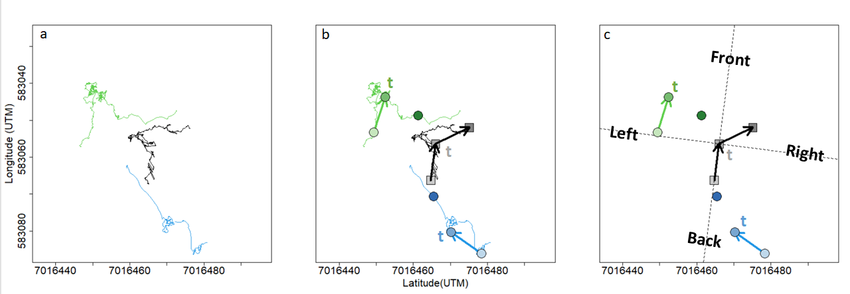Figure 2. Summary of data processing for a given time point. (a) Portions of meerkat movement trajectories collected from GPS collars. Green and blue lines represent the trajectories of two example individuals over a 20 minutes interval. Black line represents the trajectory of the group centroid over the same time-interval, obtained by averaging the coordinates of every individuals in the group (only two individuals represented). (b) At time t, velocity vectors are calculated from the points 10 meters in the past and 10 meters in the future. Lighter symbols represent positions earlier in time, darker ones represent symbols later in time. (c) The velocity vector of the centroid from the past is used to define an orthonormal basis (dashed line) relative to which the position and movement of all individuals are calculated. Based on the centroid velocity vector from the future, the group is defined as either turning left or turning right, and either speeding up or slowing down at time t. Influence metrics are derived from the individual velocity vectors from the past. In this example, the blue individual would have a positive position turning influence at time t as it was on the right side of the group before the group turned right, but a negative movement turning influence as it was moving towards the left before the group turned right. It is the opposite for the green individual.

Exploratory analyses had shown that the probability of the group to turn right increased sharply as individual position or movement towards the right increased, before plateauing (figure 3), and likewise, group probability to speed up increased as individual’s speed front-back position or movement also increased (see supplements).

We therefore modelled each of the four influences as a binary group response as a function of a continuous individual predictor: (1) probability of the group to turn right as a function of individual left-right position, (2) probability of the group to turn right as a function of individual left-right movement, (3) probability of the group to speed up as a function of individual front-back position, (4) probability of the group to speed up as a function of individual front-back movement.

The models used were a modified version of the logistic function (equation 1):

Where α represents the probability that the group is influenced by the focal individual at a given time point, β is the logistic growth rate (steepness) of the curve, and γ represent the baseline probability of the group either turning right or speeding up. We therefore consider that the group movement outcome (either turning left/right or speeding up/slowing down) has a probability α to be influenced by a given individual, in which case it follows a standard logistic function (first term of the equation), or is decided regardless of the position or movement of the focal individual, at a probability (1- α). γ was set as 0.5 for the two turning influence metrics (equal probability to turn left or right), and as the overall probability of a given group to speed up over all time points for the two speeding influence metrics.

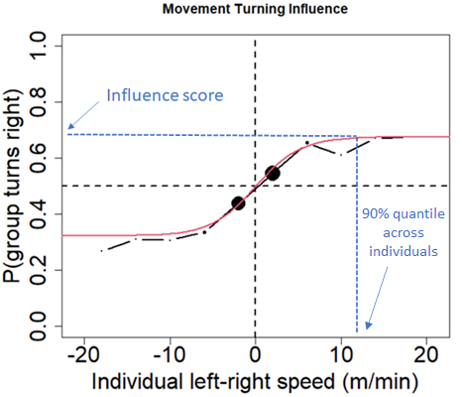We computed the fitted values of α and β for each four influence metrics by maximizing the log-likelihood of the function. We then computed the 90% quantile of each four continuous predictor variables across all individual and used the predicted probability from the model for that x-value as a score representing that individual’s influence (figure 3). This influence score therefore corresponds to the probability that the group is positively influenced by the focal individual for a fixed value of position or speed relative to the group centroid.

Figure 3. Example for one given individual of the probability that the group turns right relative to its past direction of travel as a function of that individual speed along the left-right axis. Positive x-values indicates that the individual was moving towards the right of the group relative to past direction of travel, negative values indicate it was moving towards the left. Black curve shows the real data (binned every 4 x-units), red curve shows the fitted line from the model, blue dotted lines shows how the influence score is found for that individual.

Once we had calculated the four influence scores for all individuals within each five groups we performed GLMMs with each influence score as the response variable, status as a categorical predictor and group as a random effect to test if there were consistent differences between the influence of each status.

In order to test the global interaction between position and movement of the focal individual and to know which cue is the most influential, we also modelled the probability of the group to turn right as a function of both individual left-right position and individual left-right movement, and the probability of the group to speed up as a function of both individual front-back position and individual front-back movement (equation 2). We fitted the two models across all individuals instead of separately for each individual.

*Proportion of time in the front:*

In order to see how our influence metrics related to another metric commonly assumed to reflect influence, we calculated the proportion of time each individual was spending in the front half of the group.

At time t, a given individual was considered in the front half of the group if its front-back position (x-value within the centroid reference frame, see above) was positive. In order to see the variation in the propensity to be in the front between individuals and across groups, we computed the proportion of time points an individual was in the front half in time segments of one hour. We also looked at the correlation between the total proportion of time spent in the front for each individual and their turning and speeding influence scores.

**RESULTS**

**Influence of individual position VS individual movement:**

Using the model described by equation 2, we found that across all individuals, though individual left-right position was positively correlated with the probability of the group to turn right, individual left-right speed had a much greater influence (figure 4a). In other terms, the probability of the group to turn right increases more as an individual’s movement towards the right increase, than as an individual’s position along the left-right axis increases. Similarly, the probability of the group to speed up was influenced more by individual front-back movement than by individual front-back position (figure 4b.)

Because these results show that individual movement is a more important cue than individual position in influencing the rest of the group’s direction and speed, the rest of the result focuses on movement turning and speeding influence rather than on position turning and speeding influence.

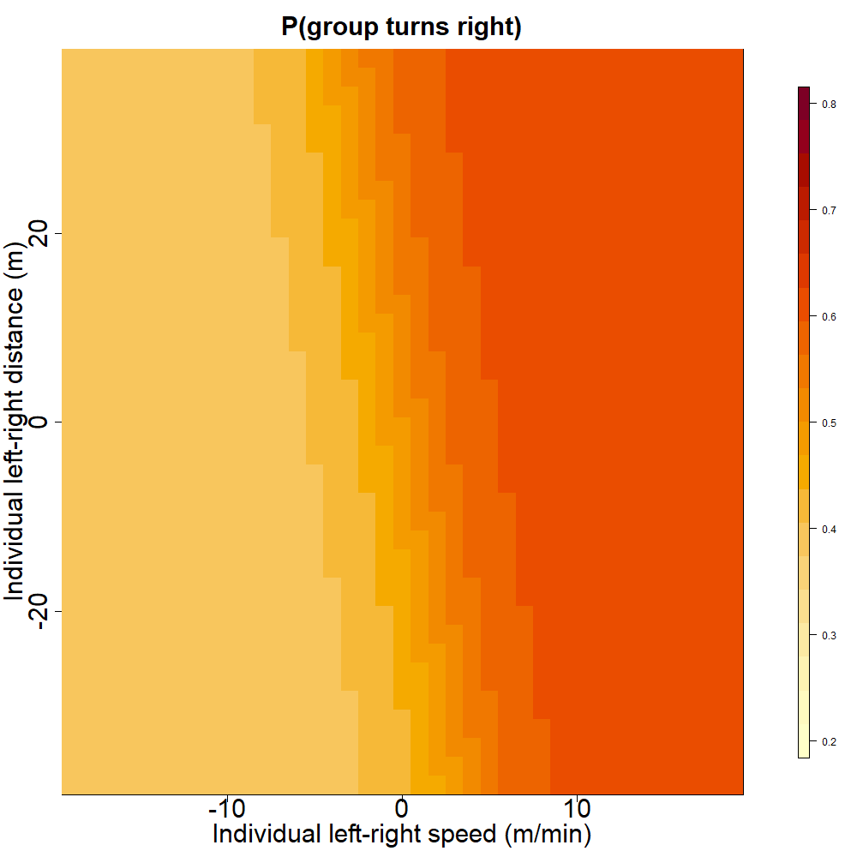

a.

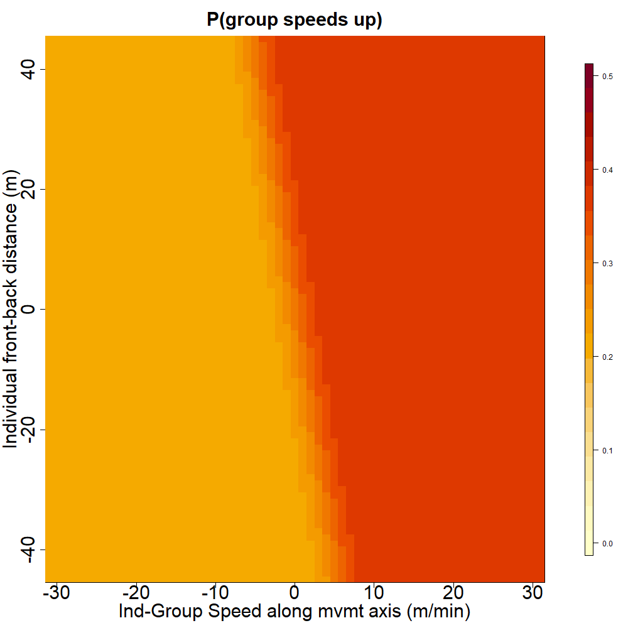

b.

Figure 4. (a) Turning influence: Probability that the group turns towards the right relative to its past direction of movement as a function of individual left-right position and left-right movement. (b) Speeding influence: Predicted probability that the group speeds up relative to its past speed, as a function of individual position and group-individual difference in speed along the front-back axis of travel. Extent of the axes correspond to the 99% quantiles of the variables across all indviduals.

**Movement turning influence and movement speeding influence scores across social statuses:**

We found a significant effect of status on movement turning influence score, with group taken into account as a random factor (figure 5a, F = 5.19 ; DF = 40 ; p-value = 0.0018), with the dominant female’s score consistently being the highest or second highest of her group. Post-hoc Tukey tests (see Supplements) showed that the score of dominant females was overall significantly higher than the scores of each subordinate status (non-dominant adults, yearlings and sub-adults), whereas the score of the dominant male was not significantly different from the scores of subordinate status.

There also was a significant difference between the movement speeding influence score of different statuses, with group taken into account as a random factor (figure 5b, F = 3.95 ; DF = 40 ; p-value = 0.0086). Post-hoc Tukey tests (see supplements) showed that the score of dominant females was significantly higher than the score of yearlings and sub-adults but was not significantly different from the score of dominants males and non-dominant adults. The score of the dominant male was not significantly different from the scores of subordinate status.

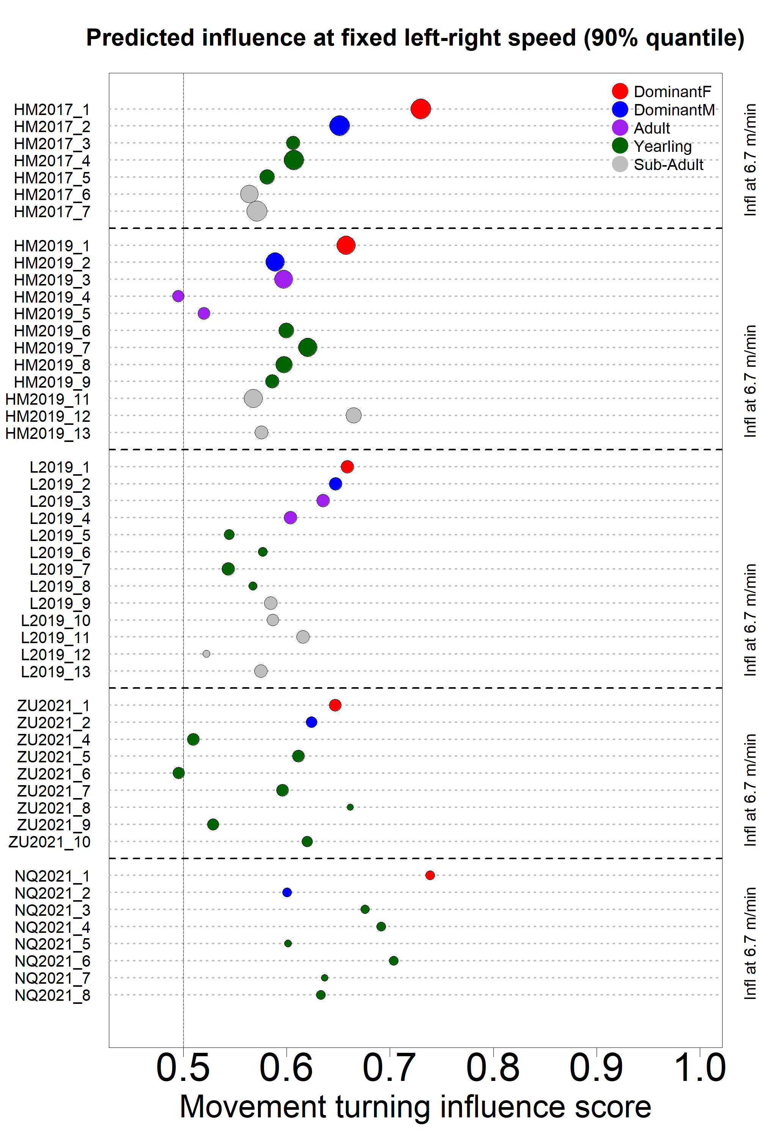

**a.**

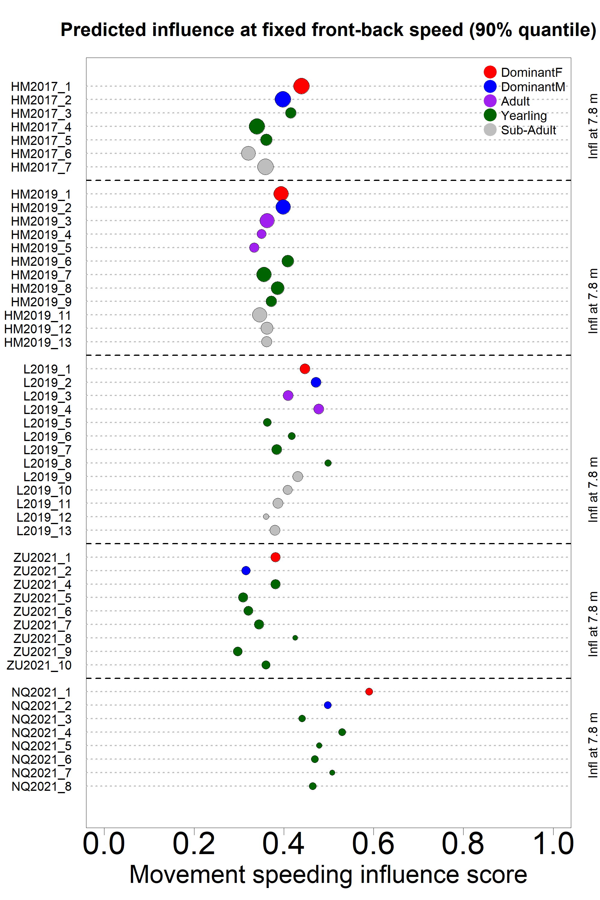

**b.**

Figure 5. Predicted influence scores for each recorded individual (colored dots) in the 5 study groups (vertical axis). Dot color indicates individual status as shown in the legend, dot size is proportional to the quantity of data available. (a) Turning influence score represents the probability that the group turns toward the same direction (left or right) that individual was moving to. (b) Speeding influence score represents the probability that the group speeds up after that individual had sped up towards the front of the group.

**Influence vs time spent in the front:**

We found the proportion of time spent by each status in the front half of the group relative to direction of travel to be relatively variable between groups (figure 6). The overall proportion of time spent in the front by the dominant female was the highest in two groups (HM17 and HM19), the second highest in one group (NQ21), and the lowest in one group (ZU21). The dominant male was rather more in the back half of the group, except in L2021. No overall trend seems to emerge for other statuses.

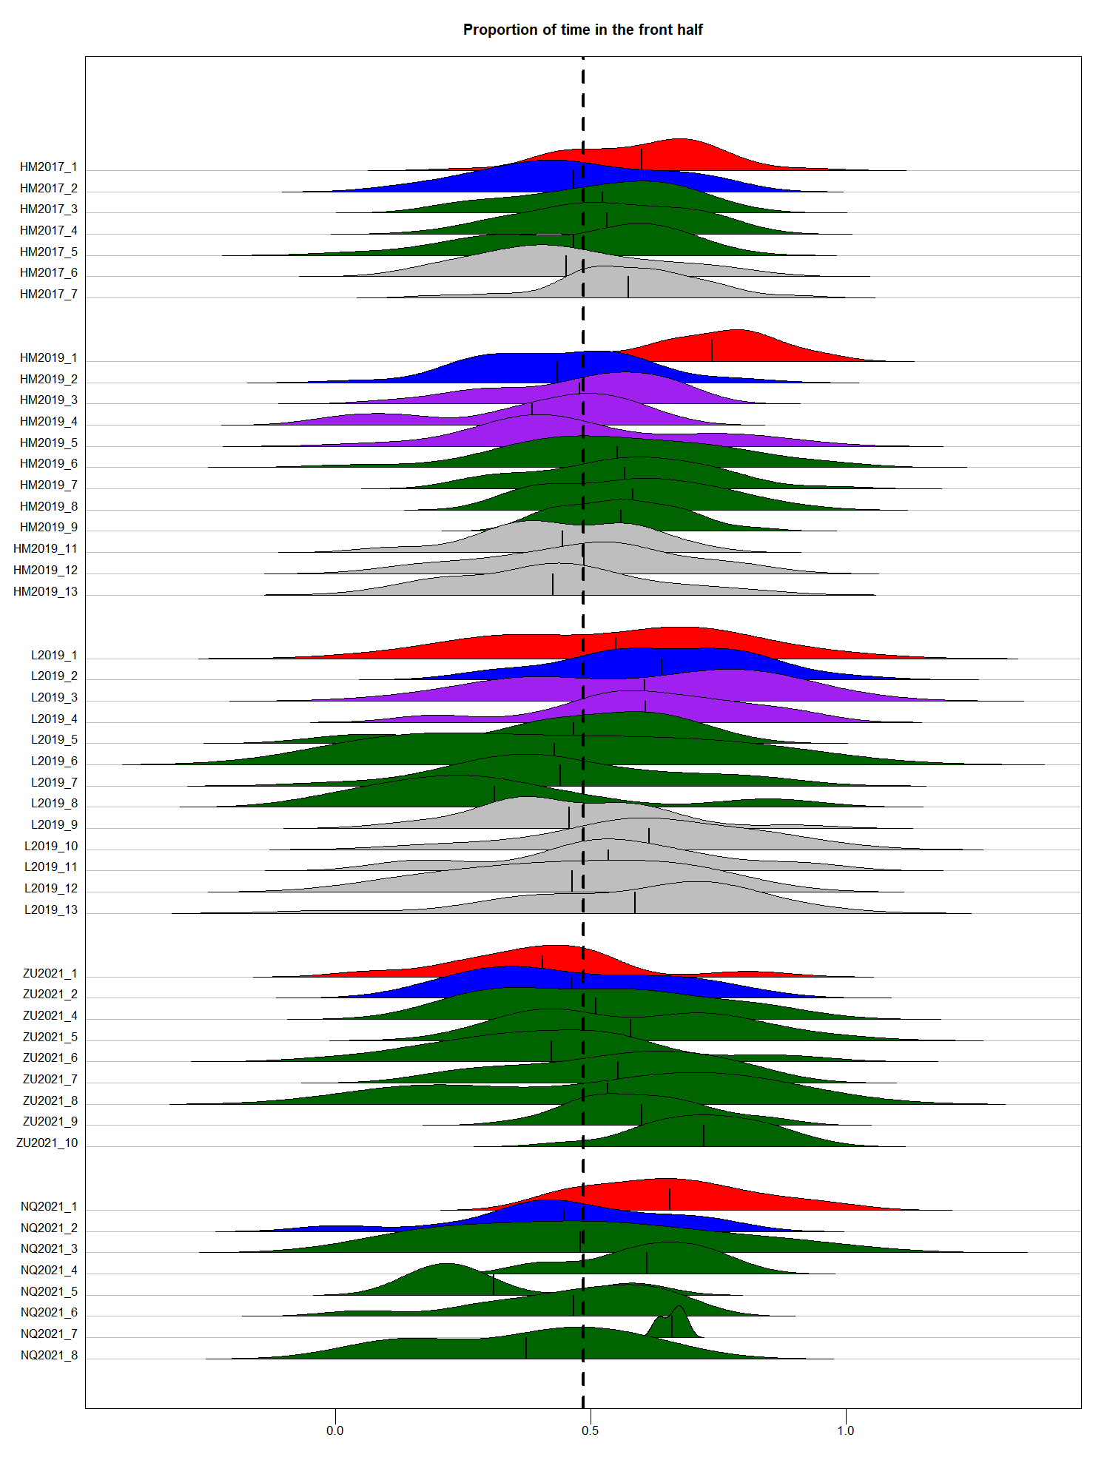

Figure 6. Distribution of the proportion of time points spent in the front half of the group over one-hour time period, for each individuals in the 5 study groups (vertical axis). Shape color indicates individual status as shown in the legend. Black vertical lines within each shape indicates the overall mean proportion of time spent in the front half of the group for that individual. Vertical dotted line indicates equal amount of time spent in the front and in the back half of the group.

We found a positive correlation between individual movement turning influence score and overall proportion of time spent in the front half (figure 7.a, F=6.039 ; DF = 47 ; p-value = 0.018), but no correlation between individual movement speeding influence and overall proportion of time spent in the front half (figure 7.a, F=0.628 ; DF = 47 ; p-value = 0.432).

Figure 7. Individual movement turning influence score (a) and movement speeding influence score (b) as a function of overall proportion of time spent in the front half of the group. Each dot represents one individual, with color indicating status and shape indicating group.

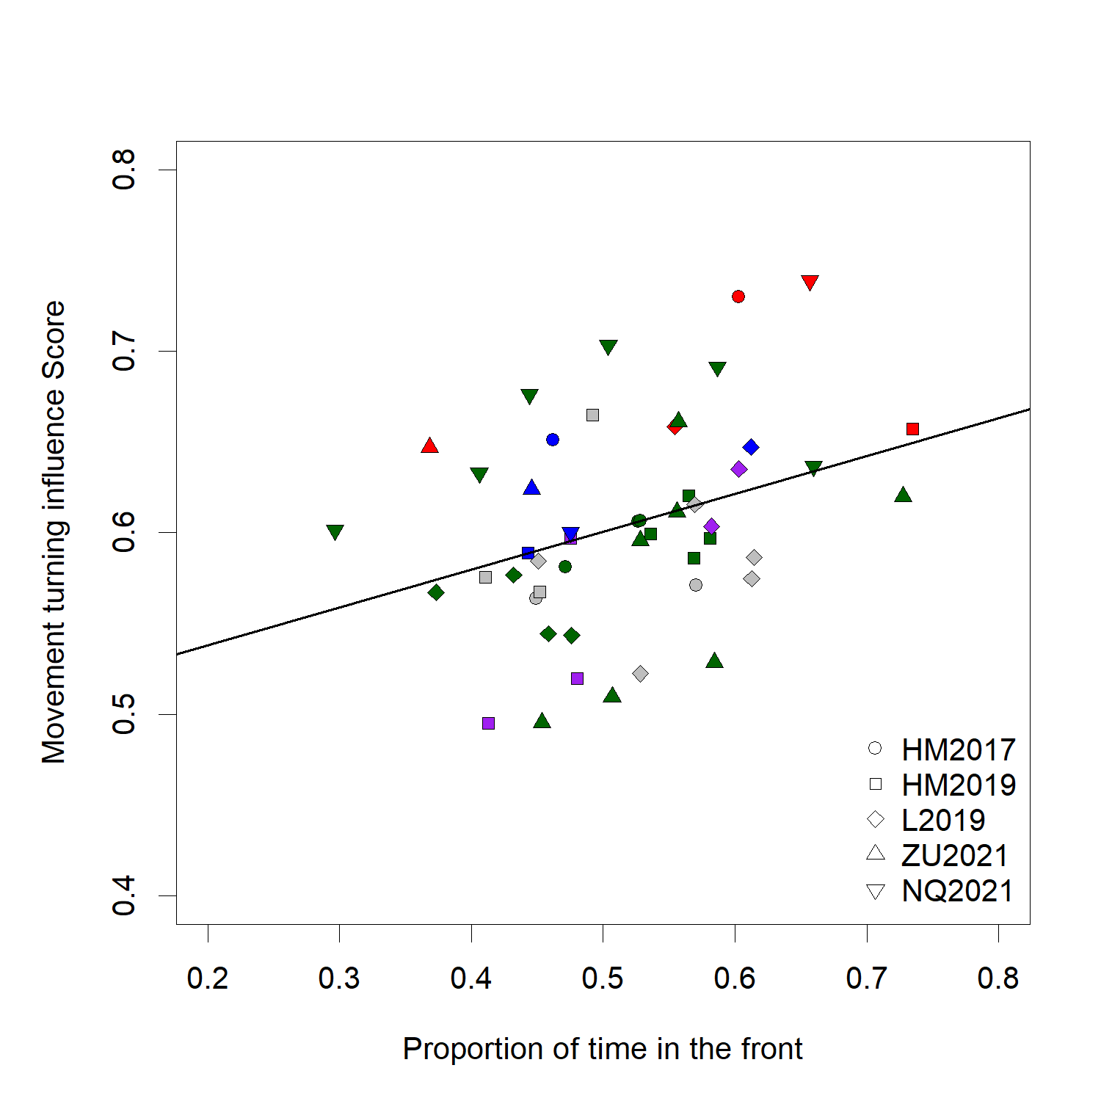

**a.**

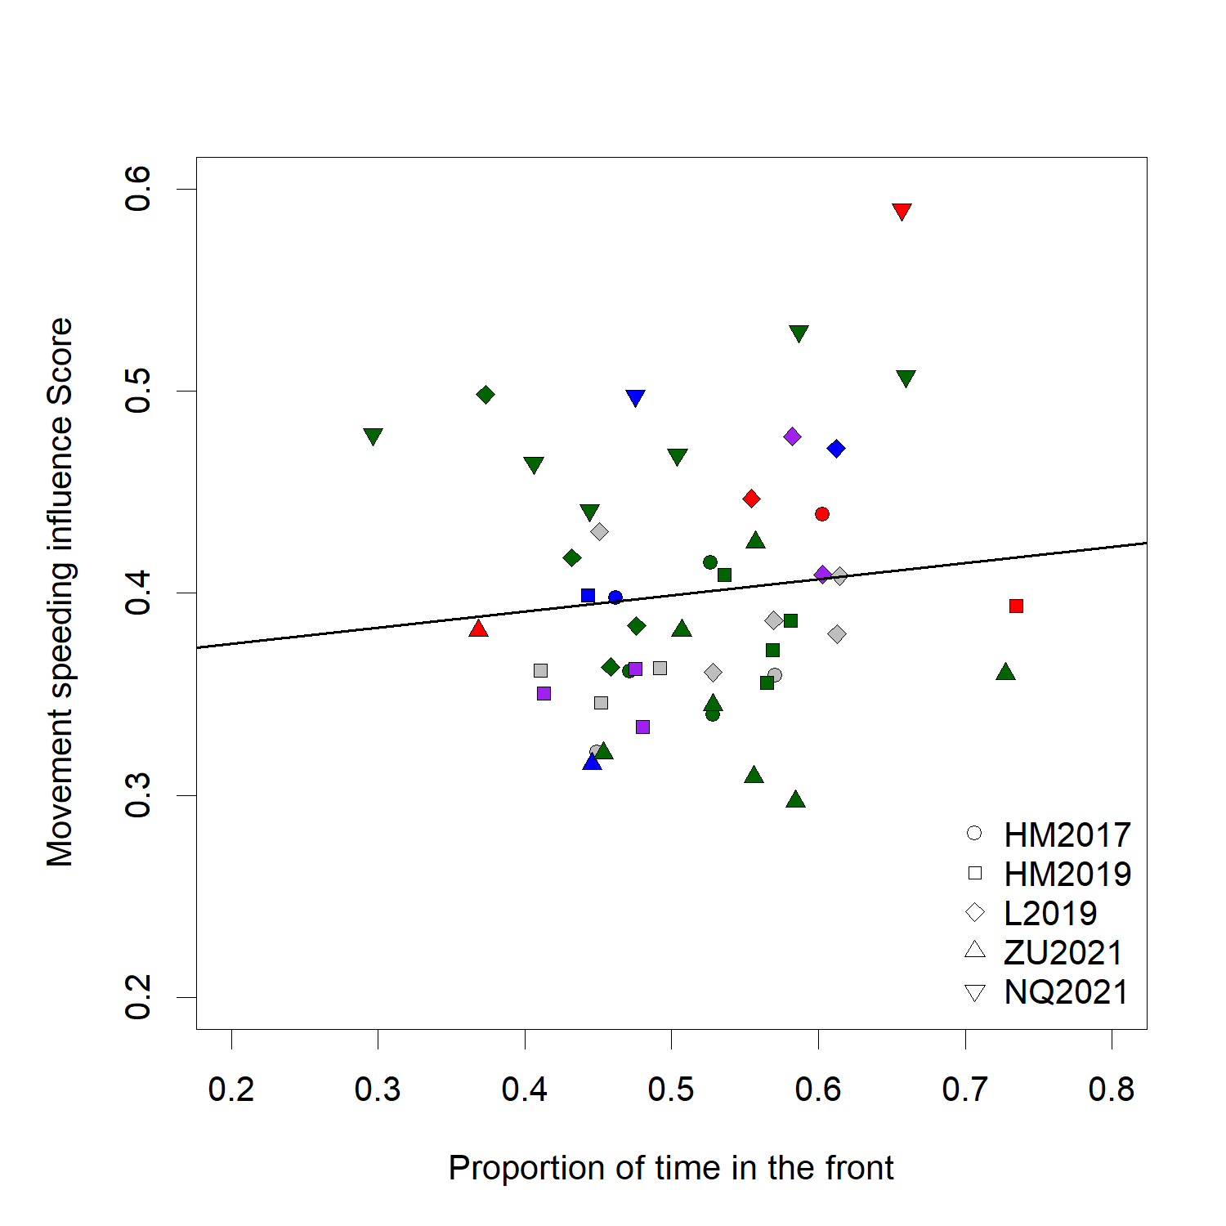

**b.**

**DISCUSSION**

In this study, we analyzed simultaneous movement trajectories of most individuals in social groups of highly cohesive meerkats while foraging. We measured the probability that the group would turn towards a given direction or change its speed depending on the position and movement of focal individuals as proxies for their influence, and compared those between social statuses. We also calculated the average position of each individual along the axis of movement, in order to compare one’s turning or speeding influence with its propensity to be in the front of the group. The comparison of five different groups as well as the use of different, complementary metrics to measure influence allow us to draw nuanced conclusions regarding mechanisms of collective decision-making in meerkats.

In order to define influence within a given social system, it is important to know something about the decision-making mechanisms at play, and in particular the type of cues that individuals follow (Strandburg-Peshkin et al. 2018). Here we found that both the position of individuals relative to others and their movement in particular directions are linked with the direction and speed of the rest of the group to some extent. However, when looking at the interaction between position and movement, we found that overall the latter is more important than the former in predicting which direction the group is going to go next, or when it will accelerate. Though classical models of collective movement (REF) or controlled studies of moving animal groups (REF) often find individual position to be an important predictor of where other individuals are going to be moving next, our findings make sense in the light of the particular type of movement exhibited by meerkat groups. Indeed, contrary to animals in the studies cited above which tend to be always in polarized motion and for which therefore position is a strong indicator of direction, a lot of the time each individual meerkat is foraging independently from others while the group as a whole is relatively stationary, thus their position in the group doesn’t necessarily entail the direction where they want to go next. Rather, our results indicate that meerkat’s likelihood to influence the group’s direction of movement increases with the speed at which they move in that particular direction. Individuals thus likely draw information more from the movement than the location of others. This result stresses the importance of having information about the type of movement exhibited by a collective group can be in order to study the decision-making rules they follow.

When looking for consistent differences between status across our 5 study groups, the dominant females are clear outliers in terms of turning influence: they has significantly higher movement turning influence across all groups, meaning that the rest of the group is much more likely to move towards the same direction as the dominant female, than any other statuses. The dominant male is on the other hand not significantly more likely to attract the other members of the group than the other status categories. One hypothesis as to why dominant females, in meerkat groups may influence group direction more than dominant males is that they have more experience within the territory. Meerkat group territories vary little within the course of individual’s lives (Kranstauber et al. 2019), so individuals who have spent more time within a given group are therefore the most experienced ones in terms of navigating within this group’s home range, and should thus be more likely to be followed by other less experienced individuals Because males are generally the dispersing sex in meerkats, dominant males, though often older than their female counterparts, are typically non-natal and hence have usually not spent as much time in the group territory (S.P. Doolan and Macdonald 1996; Griffin et al. 2003; Mares et al. 2014). As a consequence, dominant females are therefore usually the eldest natal individuals of their groups. This is the case for four out of the five groups studied, NQ21 group is and exception, where 2 subordinate individuals were born in the same litter as the dominant female (NQ2021_3 and NQ2021_4), and it is noteworthy that they too had fairly high turning influence scores (Fig.2a). It is however surprising that we found no differences in turning influence between subordinate statuses (non-dominant adults, yearlings, and sub-adults), as according to our reasoning older age class statuses would be expected to have more influence. It is thus likely that knowledge of the home range, in combination with dominance status, are aspects significantly contributing to increase a meerkat’s influence on the group’s direction of movement. This also highlights the benefits provided by the availability of long-term data in interpreting short-term results.

Individuals with high movement turning influences also tended to have high movement speeding influences (see supplements), but in contrast to turning influence, there were fewer striking differences between statuses in terms of speeding influence. In particular, all adult statuses (dominant female, dominant male and other adults) had a similar chance of speeding the group up when they were moving faster than the centroid, or slowing it down when moving slower than the centroid. The dominant female therefore seems to have more influence over the direction of travel of the group, than over its speed. Decisions about direction of movement and decisions about speed (i.e. timing) of movement, usually differ in that the former are discrete whereas the latter are continuous (Conradt and Roper 2010). In the case of meerkats, this could mean that contrary to movement timing decision, sub-optimal decisions regarding the direction of movement could end up being very costly for all individuals in the groups, as they could end up in a location with little food, far from shelter or sleeping burrows, or in rival territories. Thus, it makes sense that influential individuals are more likely to emerge in decisions involving directions, in the traits of more experienced meerkats like the dominant female. Given our results, influence over group speed could be either distributed, with all or most adults contributing to the decision to speed up or not at a given moment, or varying in time between group members, with individuals taking turn influencing others to speed up or slow down. Unfortunately, our methodology does not allow us to disentangle between these two options. Because speed of the group could have repercussions on individuals’ ability to locate food, and because quorum mechanisms, akin to a voting process by which a certain threshold of individuals giving a specific type of call is required for the group to start moving, have already been shown in meerkats (Bousquet et al. 2011), in future works it could be very interesting to incorporate data about individual foraging success, as well as vocalizations, within our influence framework, to further our understanding of the interactions between these three aspects.

The tendency to be in the front of the group is often taken as a proxy for leadership in studies of collective animal movement. Here we did find a positive correlation between movement turning influence and proportion of time spent in the front half of the group. However, when looking specifically at the status with the highest turning influence within their group, dominant females, we see that they are not necessarily more in the front than other members of the group. In particular, in L19, the dominant female spent a similar amount or less time in the front than many other individuals in her group, and in ZU21, the dominant female is the individual who spent the least amount of time in the front of the group, despite both having the highest turning influence score of their group. These results highlight that individuals in moving social groups don’t necessarily need to be at the front position in order to influence group direction. Being in the front is most likely to be linked with influence in environments where visibility is high and in species where information is transferred primarily through vision (e.g. fish, Strandburg-Peshkin et al. 2013; Rosenthal et al. 2015). However in the Kalahari desert, tall sour grass or bushes often impede visibility (REF), so front position does not necessarily offer better spatial information. Also, meerkat have the potential to convey information, and therefore influence others, from anywhere in the group thanks to their highly developed vocal communication system. What follows from this is that, depending on the species, the ordering of individuals along the axis of movement alone might not necessarily be a reliable metric to infer influence and should be used in complement with other metrics. Indeed, simply relying on the proportion of time spent in the front would have led to incomplete conclusions regarding patterns of influence in our case. it is worth noting that the one dominant female which was spending more time in the back (group ZU21) had by far the longest tenure at the time of data collection amongst dominant females of our study (104 weeks against 38 weeks maximum, see supplements). This could be an indication that as a female’s dominancy becomes more established within a group, they might increase their influence on the group from any position.

**CONCLUSION**

Overall our results seem to indicate several trends regarding influence dynamics in meerkat groups: individuals can influence the direction and speed of the group by their movement in certain direction more than by their position within the group, the dominant female has the most influence over direction of travel but not necessarily over speed of travel, and the most influential individuals are not always the one who are more in the front of the group. The methodology and results we presented highlights the versality of such a trait as influence and therefore the need to study it from different perspective, using when possible several groups, and with a good knowledge of the species’ life history and movement characteristics, to draw a picture as least incomplete as possible. Since our method captured measures of influence aggregated over time, it could be interesting in future work to contrast it with complementary approaches, for instances identifying particular events in the trajectory, like sharp changes in direction or increases in speed during movement, in order to get a more complete pictures of the distribution and variability of influence in meerkats. Integrating the use of vocalizations within this framework would likely also prove very insightful. Because of its generality, our method could be used, with potential expansions or adjustments, in other animal systems to allow comparisons of the mechanisms at play during decision of speed and direction of movement in social species.

**BIBLIOGRAPHY**

Bousquet CAH, Manser MB. 2011. Resolution of experimentally induced symmetrical conflicts of interest in meerkats. Animal Behaviour. 81(6):1101–1107. doi:10.1016/j.anbehav.2011.02.030.

Bousquet CAH, Sumpter DJT, Manser MB. 2011. Moving calls: a vocal mechanism underlying quorum decisions in cohesive groups. Proceedings of the Royal Society of London B: Biological Sciences. 278(1711):1482–1488. doi:10.1098/rspb.2010.1739.

Clutton-Brock TH, Brotherton PNM, O’Riain MJ, Griffin AS, Gaynor D, Kansky R, Sharpe L, McIlrath GM. 2001. Contributions to cooperative rearing in meerkats. Animal Behaviour. 61(4):705–710. doi:10.1006/anbe.2000.1631.

Clutton-Brock TH, Maccoll A, Chadwick P, Gaynor D, Kansky R, Skinner JD. 1999. Reproduction and survival of suricates (Suricata suricatta) in the southern Kalahari. African Journal of Ecology. 37(1):69–80. doi:10.1046/j.1365-2028.1999.00160.x.

Conradt L, Roper TJ. 2010. Deciding group movements: where and when to go. Behavioural processes. 84:675–677. doi:10.1016/j.beproc.2010.03.005.

Couzin ID, Krause J, Franks NR, Levin SA. 2005. Effective leadership and decision-making in animal groups on the move. Nature. 433(7025):513–516. doi:10.1038/nature03236.

Doolan S, Macdonald D. 1996. Diet and foraging behaviour of group living meerkats, Suricata suricatta, in the southern Kalahari. Journal of Zoology. 239:697–716.

Doolan SP, Macdonald DW. 1996. Dispersal and extra-territorial prospecting by slender-tailed meerkats (Suricata suricatta) in the south-western Kalahari. Journal of Zoology. 240(1):59–73. doi:10.1111/j.1469-7998.1996.tb05486.x.

Doolan SP, Macdonald DW. 1997. Breeding and juvenile survival among slender-tailed meerkats (Suricatu suricatta) in the south-western Kalahari: ecological and social influences. Journal of Zoology. 242(2):309–327. doi:10.1111/j.1469-7998.1997.tb05804.x.

Gall GEC, Manser MB. 2017. Group cohesion in foraging meerkats : follow the moving ‘ vocal hot spot ’. Royal Society Open Science.

Gall GEC, Strandburg-Peshkin A, Clutton-brock T, Manser MB. 2017. As dusk falls : collective decisions about the return to sleeping sites in meerkats. 132:91–99.

Garland J, Berdahl AM, Sun J, Bollt EM. 2018. Anatomy of leadership in collective behaviour. Chaos. 28(7):075308. doi:10.1063/1.5024395.

Giuggioli L, McKetterick TJ, Holderied M. 2015. Delayed Response and Biosonar Perception Explain Movement Coordination in Trawling Bats. PLOS Computational Biology. 11(3):e1004089. doi:10.1371/journal.pcbi.1004089.

Griffin AS, Pemberton JM, Brotherton PNM, McIlrath G, Gaynor D, Kansky R, O’Riain J, Clutton-Brock TH. 2003. A genetic analysis of breeding success in the cooperative meerkat (Suricata suricatta). Behavioral Ecology. 14(4):472–480. doi:10.1093/beheco/arg040.

Herbert-Read JE. 2016. Understanding how animal groups achieve coordinated movement. Journal of Experimental Biology. 219(19):2971–2983. doi:10.1242/jeb.129411.

Hughey LF, Hein AM, Strandburg-Peshkin A, Jensen FH. 2018. Challenges and solutions for studying collective animal behaviour in the wild. Phil Trans R Soc B. 373(1746):20170005. doi:10.1098/rstb.2017.0005.

Jolles JW, Boogert NJ, Sridhar VH, Couzin ID, Manica A. 2017. Consistent Individual Differences Drive Collective Behavior and Group Functioning of Schooling Fish. Current Biology. 27(18):2862-2868.e7. doi:10.1016/j.cub.2017.08.004.

Katz Y, Tunstrøm K, Ioannou CC, Huepe C, Couzin ID. 2011. Inferring the structure and dynamics of interactions in schooling fish. PNAS. 108(46):18720–18725. doi:10.1073/pnas.1107583108.

Kerth G, Ebert C, Schmidtke C. 2006. Group decision making in fission–fusion societies: evidence from two-field experiments in Bechstein’s bats. Proceedings of the Royal Society B: Biological Sciences. 273(1602):2785–2790. doi:10.1098/rspb.2006.3647.

Kranstauber B, Gall GEC, Vink T, Clutton‐Brock T, Manser MB. 2019. Long-term movements and home-range changes: Rapid territory shifts in meerkats. Journal of Animal Ecology. n/a(n/a). doi:10.1111/1365-2656.13129. [accessed 2019 Dec 19]. https://besjournals.onlinelibrary.wiley.com/doi/abs/10.1111/1365-2656.13129.

Lewis JS, Wartzok D, Heithaus MR. 2011. Highly dynamic fission–fusion species can exhibit leadership when traveling. Behav Ecol Sociobiol. 65(5):1061–1069. doi:10.1007/s00265-010-1113-y.

Manser MB, Clutton‐Brock TH. 2016. Meerkats: cooperative breeding in the Kalahari. In: Koenig WD, Dickinson JL, editors. Cooperative Breeding in Vertebrates. Cambridge University Press.

Manser MB, Jansen DAWAM, Graw B, Hollén LI, Bousquet CAH, Furrer RD, le Roux A. 2014. Vocal Complexity in Meerkats and Other Mongoose Species.

Mares R, Bateman AW, English S, Clutton-Brock TH, Young AJ. 2014. Timing of predispersal prospecting is influenced by environmental, social and state-dependent factors in meerkats. Animal Behaviour. 88:185–193. doi:10.1016/j.anbehav.2013.11.025.

Montanari D, O’Hearn WJ, Hambuckers J, Fischer J, Zinner D. 2021. Coordination during group departures and progressions in the tolerant multi-level society of wild Guinea baboons (Papio papio). Sci Rep. 11(1):21938. doi:10.1038/s41598-021-01356-6.

Nagy M, Ákos Z, Biro D, Vicsek T. 2010. Hierarchical group dynamics in pigeon flocks. Nature. 464(7290):890–893. doi:10.1038/nature08891.

Papageorgiou D, Farine DR. 2020. Shared decision-making allows subordinates to lead when dominants monopolize resources. Science Advances. 6(48):eaba5881. doi:10.1126/sciadv.aba5881.

Pettit B, Ákos Z, Vicsek T, Biro D. 2015. Speed Determines Leadership and Leadership Determines Learning during Pigeon Flocking. Current Biology. 25(23):3132–3137. doi:10.1016/j.cub.2015.10.044.

Rosenthal SB, Twomey CR, Hartnett AT, Wu HS, Couzin ID. 2015. Revealing the hidden networks of interaction in mobile animal groups allows prediction of complex behavioral contagion. PNAS. 112(15):4690–4695. doi:10.1073/pnas.1420068112.

Smith JE, Estrada JR, Richards HR, Dawes SE, Mitsos K, Holekamp KE. 2015. Collective movements, leadership and consensus costs at reunions in spotted hyaenas. Animal Behaviour. 105:187–200. doi:10.1016/j.anbehav.2015.04.023.

Strandburg-Peshkin A, Clutton-Brock T, Manser MB. 2020. Burrow usage patterns and decision-making in meerkat groups. Behavioral Ecology. 31(2):292–302. doi:10.1093/beheco/arz190.

Strandburg-Peshkin A, Clutton-Brock T, Manser MB. 2019. Burrow usage patterns and decision-making in meerkat groups. Behav Ecol. doi:10.1093/beheco/arz190. [accessed 2019 Nov 8]. https://academic.oup.com/beheco/advance-article/doi/10.1093/beheco/arz190/5613753.

Strandburg-Peshkin A, Farine DR, Couzin ID, Crofoot MC. 2015. GROUP DECISIONS. Shared decision-making drives collective movement in wild baboons. Science. 348(6241):1358–1361. doi:10.1126/science.aaa5099.

Strandburg-Peshkin A, Papageorgiou D, Crofoot MC, Farine DR. 2018. Inferring influence and leadership in moving animal groups. Philosophical transactions of the Royal Society of London Series B, Biological sciences. 373(1746):20170006–20170006. doi:10.1098/rstb.2017.0006.

Strandburg-Peshkin A, Twomey CR, Bode NWF, Kao AB, Katz Y, Ioannou CC, Rosenthal SB, Torney CJ, Wu HS, Levin SA, et al. 2013. Visual sensory networks and effective information transfer in animal groups. Current Biology. 23(17):R709–R711. doi:10.1016/j.cub.2013.07.059.

Tokuyama N, Furuichi T. 2017. Leadership of old females in collective departures in wild bonobos (Pan paniscus) at Wamba. Behav Ecol Sociobiol. 71(3):55. doi:10.1007/s00265-017-2277-5.

Van Belle S, Estrada A, Garber PA. 2013. Collective group movement and leadership in wild black howler monkeys (Alouatta pigra). Behav Ecol Sociobiol. 67(1):31–41. doi:10.1007/s00265-012-1421-5.